**Practical 2**

**Aim:** Write a program to implement CRUD operations on MongoDB.

1. **Create operation:**

**Code:**

use student1

db.createCollection("student1")

**Output:**



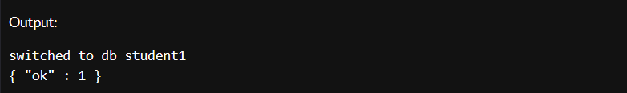**i. insert()**

**Code:**

db.student1.insert({

name: "aamina",

age: "19",

roll_no: "221"

})

**Output:**



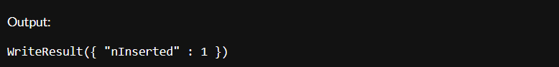

**ii. insertMany()**

**Code:**

db.student1.insertMany([{

name: "aamina",

age: "19",

roll_no: "221"},

{

name: "priyanka",

age: "19",

roll_no: "222"},

{

name: "karishma",

age: "20",

roll_no: "223"}

])

**Output:**

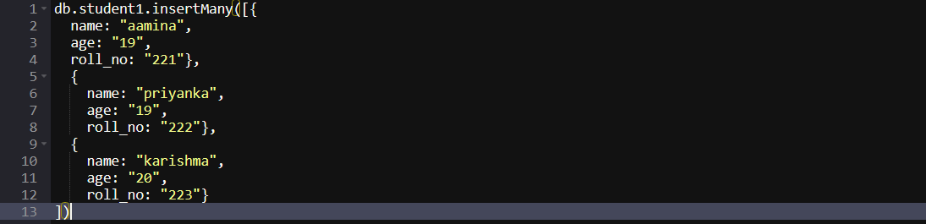

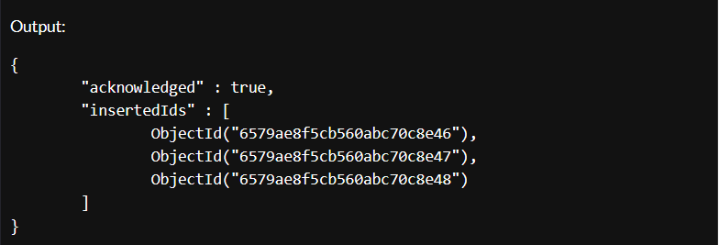

1. **Read operation:**

**i. find()**

**Code:**

db.students.find()

**Output:**



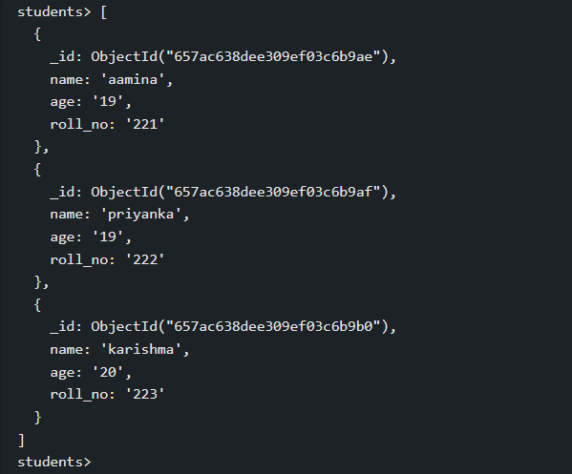

**ii. findOne()**

**Code:**

db.students.findOne({name: "aamina"})

**Output:**



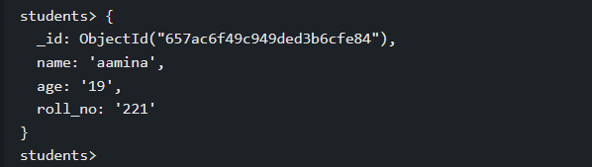

1. **Update operation**

**i. updateOne()**

**Code:**

db.students.updateOne({name: "priyanka"},{$set: {age: "21"}})

**Output:**



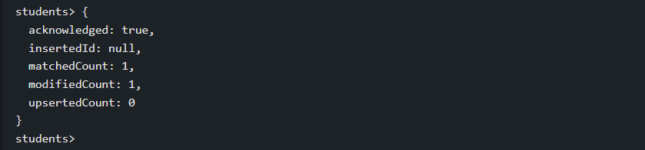

1. **Delete operation**

**i. deleteOne()**

**Code:**

db.students.deleteOne({name: "aamina"})

db.students.find()

**Output:**



